Metier description report
Josefine Egekvist, DTU Aqua
28 april, 2019

Region: North Atlantic

Metier: LLS_DEF_0_0_0 , years: 2015,2016,2017
Data source: RDB CE and CL data
Number of trips by flag countries: ESP, PRT, FRA, IRL
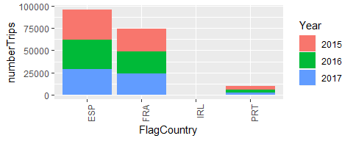
Top 10 species landed by metier. The rest are summarised in “Other species”. Average yearly landings during the period 2015,2016,2017 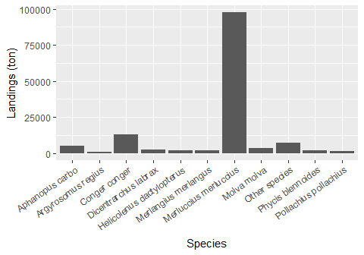

Number of vessels by vessel length group:
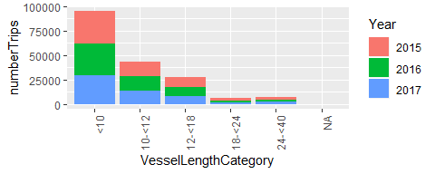
Seasonal pattern of fishing activity: Number of trips by quarter
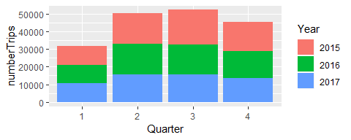
Days at Sea by ICES rectangle, yearly average 2015-2017 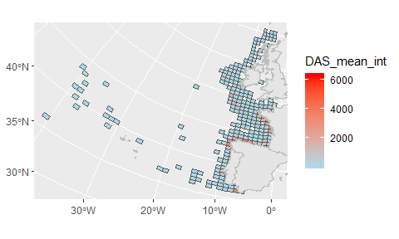
Comments:

